
SOP Title: | eCommerce C-Stock Disposition
Document Storage Location: | STACS/Management/SOPs – Logistics and Warehousing | Document #: | SEASOP437v100
SOP Originator: | Valentina Popadic | Last Edited by: | Erwin Dela Pena
Effective Date: | 07/13/2021 | Last Edited Date: | 12/12/2023
Other: | NERP Access Required.

- Purpose
  - To document processes, procedures, and standards for the eCommerce (eComm) inventory disposition for C-Stock material to also include Technical Returns.
- Scope
  - Policies and responsibilities governing Samsung eComm C-Stock shipments to Samsung Triage partner.
- Responsibilities
  - The SEA eComm Operations team shall create the PUMI and submit for approval.
  - The SEA eComm Operations team shall designate which Samsung Triage partner will be forwarded the C stock units
  - The 3PL eComm team (3PL) shall create inventory reports using their Warehouse Management System (WMS) to provide to SEA eComm teams.
  - The SEA Logistics, Planning & Shared Services (LPS) eComm team shall manage communication with Triage partner.
  - The LPS eComm team shall utilize NERP to keep records of C-stock.
- Instructions
  - LPS team provides how many units of C-Stock SKUs should be sent to the triage partner.
    - In the Geodis Visibility system, request the report, ‘Samsung_Location_by_Inventory_Status_Report’ and download the file.
    - Once downloaded, perform the following:
      - Filter for items that have a numerical bin location such as 111020A01, 111020A01, etc. and ‘CP’ Inventory status. Create a pivot table to summarize the counts for each sku.
    - In NERP
      - Run MB52 T-code.
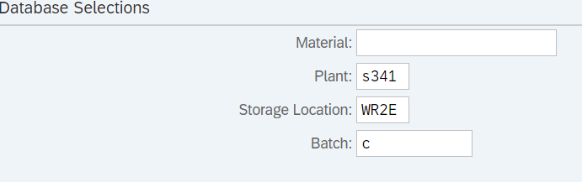

      - Enter Plant S341
      - Enter Storage Location WR2E
      - Enter Batch C
      - Click on the Execute button
      - Download the NERP file.
      - Once downloaded, create a pivot table summary that shows the sku and total qty. The quantity to use is located in the ‘Unrestricted” column of the sheet.
    - Create C-Stock Comparison Report: Compare quantities of the NERP file with ‘Samsung_Location_by_Inventory_Status_Report’
      - Compare the 2 counts from the report and select the lower of the 2 numbers.
      - Final numbers from the comparison file are shared with SEA eComm Operations contact for PUMI submission.
PivotTable of available B-Stock report in 3PL WMS

  - LPS team sends the C-Stock report to
    - SEA eComm Operations team contact:
      - Charles Kim: charles1.k@partner.sea.samsung.com
  - PUMI Creation and Approval
    - SEA eComm Operations team creates the PUMI and submits for approval.
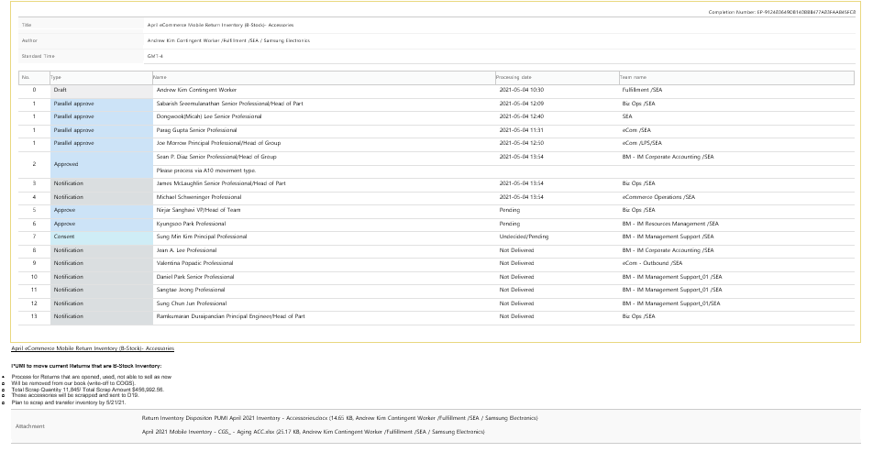
Example of C-Stock PUMI
    - SEA eComm Operations team designates in the PUMI which disposition of requested C stock.
    - LPS team is notified of Approved PUMI via email.
    - The LPS team will provide the list of items to be picked to the 3PL and determines the due date for pickup.
    - LPS will arrange for transportation based on due date for pickup.
      - Send request to email: SEA-Transportation@sea.samsung.com
    - 3PL begins the picking process.
  - Picking Process
    - LPS team
      - Forwards the list of items to 3PL.
      - Work order is submitted to LPS for approval.
      - Requests 3PL to start pulling the approved quantity.
      - The pull list should contain
        - Item
        - Item UPC
        - SKU Type
        - Item Description
        - Authorized picked quantity
        - Total Quantity
    - 3PL Inventory Supervisor
      - Creates a separate file with locations for each item.
      - Distributes the file to the associates pulling the items.
      - Notifies LPS on pull status and specifies if there delays.
    - 3PL Inventory Team associate picks the product from their locations.
    - 3PL systematically in WMS
      - Moves the LPs (license plates) from their locations to a designated holding bin location.
    - Then, 3PL associates
      - Scan the UPC and IMEI information on product boxes into a spreadsheet as required.
      - Verify that the quantity of the scanned items matches the ‘Approved Quantity’ on the list.
    - The next morning, as a second verification the 3PL Inventory Control (IC) team performs cycle counts on the bin which containted the material.
      - Communicate discovered variances to 3PL IC Manager for further research.
    - 3PL provides list of the pulled C stock and any verified IMEIs to the LPS team.
    - LPS Inventory team member reviews the number of IMEIs and performs verification and alignment with 3PL IC Manager.
    - LPS and 3PL teams adjusts out the picked inventory in Synapse and NERP.
      - 3PL performs adjustments in 3PL WMS.
        - Use ‘SC’ (scrap) transaction code.
        - Make a comment including time stamp/PUMI sent from LPS team.
          - Allows for future research.
        - Send email to LPS team when adjustments have been completed.
          - LPS eComm email distribution list.
      - LPS performs adjustments in NERP.
        - T-Code MIGO.
        - Select A01 Goods Receipt and R10 in dropdowns
        - Movement type A10.
        - Plant S341.
        - Storage location WC1E.
        - Input Material # and quantity. Max of 30 skus at a time can be inputted.

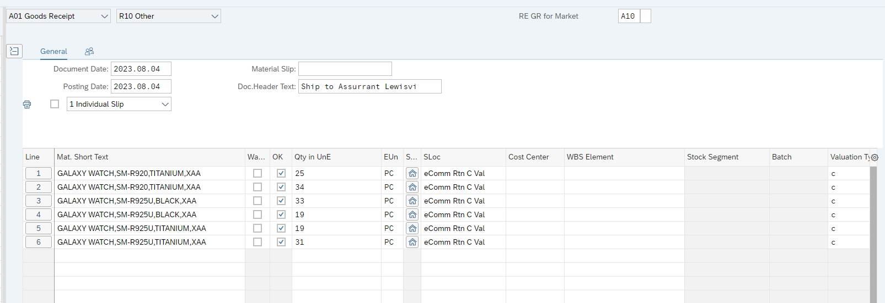

        - Click check. If green icon shows all good. If not, go back and review.
        - Click post once all green.

  - Shipment Preparation
    - Once the system adjustments are complete, the LPS team ensures all boxes are correctly labeled and palletized for transit to final destination.
  - On day of delivery, a signed BOL will be required and will be filed with the 3PL and the LPS team.
  - Technical Returns
    - The flow chart below indicates the movement of Technical Return product to DOA.

